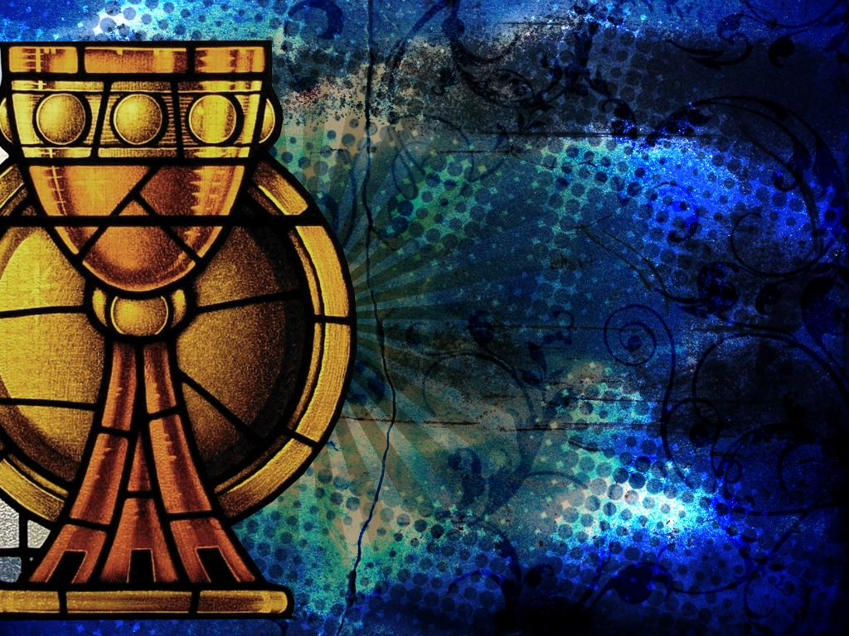**2025-2026 First Reconciliation & First Communion**

The Sacrament Program is a home-based study designed for you and your child(ren) to learn the teaching of the Catholic Church on the Sacraments of First Reconciliation and First Communion.

ALL MEETINGS ARE REQUIRED

**Parent Only Meetings at Sacred Heart Church 6:30pm-7:30pm**

Attend at least 2 of the Domestic Church Sessions.

*There will be a sign in at each meeting.*

October 8

November 12

January 14

February 12

**1st Mass & Reconciliation Meeting – Parent & Child**

October 11 at Holy Family from 4:00pm-5:30pm OR

October 12 at Holy Family from 8:00am-9:30am

**2nd Mass & Reconciliation Meeting – Parent & Child**

December 13 at Holy Family from 4:00pm-5:30pm OR

December 14 at Holy Family from 8:00am-9:30am

**Reconciliation Day (optional but encouraged) – Parent & Child**

Saturday, January 10 at Holy Family from 1:30pm-3:00pm

If you cannot attend this day it is your responsibility to make sure your child receives First Reconciliation before they make their First Communion.

**First Reconciliation Meetings**

**1st Mass & Communion Meeting – Parent & Child**

January 24 at Holy Family from 4:00pm-5:30pm OR

January 25 at Holy Family from 8:00am-9:30am

**First Communion Retreat – Parent & Child**

March 21 at Sacred Heart Church and School from 9:15am-11:00am OR

March 28 at Sacred Heart Church and School from 9:15am-11:00am

There will be a First Communion Rehearsal the week leading up to your First Communion Mass.

**First Communion Meetings**

First Reconciliation was made a requirement of First Holy Communion about 20 years ago. Therefore, we prepare and receive this Sacrament before preparing and receiving the Sacrament of Holy Communion.

First Communion Masses will be held during the Sunday Masses with the community the weekends of April 11-12, 2026 and May 2-3, 2026 (some sites may also have Baptisms). Instructions for First Communion Mass times will be discussed at the first meeting and sign-up available in January 2027.