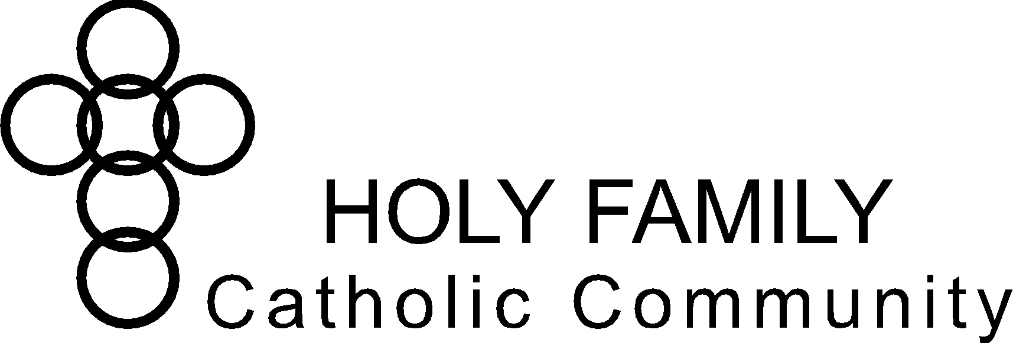

**Holy Family Catholic Community Christian Formation Commission Notes**

**April 9, 2024, 6:00pm – 7:30pm**

**Sacred Heart Victory Center**

**Commission Members:** Patti Folz,Marian Freund,Barb Piechowski, Lisa Sutton

**Pastoral Council Liaison:** Julie Baltz, Jenny Hammis, Pam Minsch, Angie Raflik

**Staff & Clergy:** Sabina Carter, Trisha Zimmerman

**Absent:** Jane Lueck, Andrea School, Fr. Matthew Kirk, Fr. Kevin Tanel

**Excused:** Nora Dee

**Guest:** Collette Jaeger

**Opening Prayer** (Jenny Hammis)

|  |  |  |
| --- | --- | --- |
| **Chair:** Angie Raflik | **Co-Chair:** Lisa Sutton | **Secretary**: Barb Piechowski |

|  |  |  |
| --- | --- | --- |
| **Holy Family Vision Statement**  To be disciples in Christ – living witness to the Good News. | **Holy Family Mission Statement**  We are a Catholic community  empowered through the Holy Spirit  to love God and follow Jesus Christ  through faith, worship, and witness. | **Important Dates:**   * 04/14/2024 – Faith Builders Club for Kids * 04/26/2024 – Peace in the Chaos, Anne Auger * 05/10/204-05/12/2024 - Vatican International Exhibition: The Eucharistic Miracles of the World * 06/10/2024-06/21/2024 - Elementary/Middle School Faith Formation (Transition to Summer Program) * 07/26/2024-07/28/2024 – High School Steubenville – St. Paul Conference |

|  |
| --- |
| **Welcome & Framing Statement:**  This commission has three purposes:   * Accountability: *CF Commission represents Holy Family parishioners and keeps CF Staff accountable to parish/parishioner needs.* * Brainstorming: *CF Commission hears issues from CF Staff and brainstorms solutions.* * Organizing Volunteers: *CF Commission actively volunteers to help organize or coordinate in CF Staff’s areas of greatest need.* |

**Old Business:**

1. Christian Formation (Staff) – Questions, Highlights (Achievements towards strategic plan) <https://www.hffdl.org/strategic/> website

[Final-Holy-Family-Strategic-Plan.pdf (hffdl.org)](https://www.hffdl.org/wp-content/uploads/2023/08/Final-Holy-Family-Strategic-Plan.pdf) plan

* + Sabina & Trisha added notes to the 2023-2028 Strategic Plan under applicable strategy.
  + The strategic plan contains four principal areas of focus: Evangelization, Study, Prayer & Generosity (Based on the 4 Signs of the Dynamic Catholic).
  + Reviewed/discussed staff notes under each strategy of Study:
    - Adult Formation (Sabina)
    - Elementary/Middle School Formation (Trisha)
    - High School Formation (Sabina)
  + Commission input on strategies under Study:
    - * + Youth Group vs Faith Formation: Youth Group is open to all youth. Faith Formation usually includes those who do not have Christian Formation program in school (public schools or others interested, all are welcome).
    - Formation vs Sacramental Prep: Confirmation, first communion, first reconciliation, etc. are separate programs. Add section for sacramental prep or include with High School and Elementary/Middle School Formation.
      * + Archdioceses curriculum guidelines (Trisha will share with Commission).
    - Discussed how to evaluate adult bible studies – participation influenced by topics, weather, and times offered, among other things. Consider formal evaluations as done with other programs. Make survey available at last session (captured audience) and ask to complete before leaving. Jot Form, QR Code.
    - Add verbal feedback as a form of evaluation for Elementary/Middle School (parents of youth).
    - Mass Cards for first reconciliation & first communion, some push-back but primarily positive response & results.
    - Transition for High School seniors to young adult parishioners – How to get Safeguarding/Safe Environment training offered. Bring forward to St. Mary’s Springs to consider adding to J -term.
    - Discussed what else we can do to Strengthen parish’s understanding of Sacred Scripture. Consider focus on resources/websites once a quarter – communicate to parishioners.
    - Formed – Promote new offerings or monthly ideas and communicate to parishioners via the Goodnews. (Marian Freund volunteered).

1. Pastoral Council Report (Angie Raflik/Julie Baltz)
   * Review of recent events
   * Update from Sara Razner
   * Sunday Evening Mass at 5pm at Marian (currently during school year)
   * Update on Clergy
   * Master Facility Plan
   * Plans/Committee for Crucifix at Holy Family
   * Starting to talk about remodel of Sacred Heart
2. Decide on meeting times for next year (Sabina)
   * Survey will be sent with meeting notes to determine upcoming meeting dates/times.

**New Business:**

1. Commission Book Read – Your God is Too Boring, Jon Leonetti (Lisa/All)

Chapters 7-Conclusion, pgs. 102-153

* What part of the assigned reading was most impactful for you?

**Closing Prayer** (Jenny Hammis)

**Agenda Items for Next Meeting:**

1. Christian Formation Report /2023-2028 Strategic Plan (Staff) – Questions, Highlights (Achievements towards strategic plan) – continue review/discussion with next section (Prayer).
2. Pastoral Council Report (Liaisons)
3. Beautiful Eucharist – Commission Book Read (Lisa Sutton)

**Closing Prayer** (Jenny Hammis)

**Next meeting:** TBD