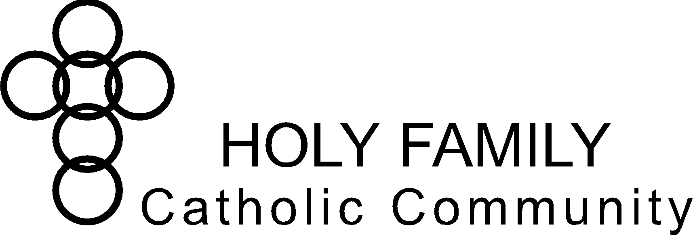

**Holy Family Catholic Community Christian Formation Commission Notes**

**January 23, 2024, 6:00pm – 7:30pm**

**Sacred Heart Victory Center**

**Commission Members:** Patti Folz, Jane Lueck, Barb Piechowski, Lisa Sutton

**Pastoral Council Liaison:** Angie Raflik

**Staff & Clergy:** Sabina Carter, Trisha Zimmerman, Fr. Matthew Kirk

**Absent:** Nora Dee, Marian Freund, Jenny Hammis, Andrea School

**Excused:** Julie Baltz, Fr. Kevin Tanel, Pam Minsch

**Opening Prayer** (Sabina Carter)

|  |  |  |
| --- | --- | --- |
| **Chair:** Angie Raflik | **Co-Chair:** Lisa Sutton | **Secretary**: Barb Piechowski |

|  |  |  |
| --- | --- | --- |
| **Holy Family Vision Statement**  To be disciples in Christ – living witness to the Good News | **Holy Family Mission Statement**  We are a Catholic community  empowered through the Holy Spirit  to love God and follow Jesus Christ  through faith, worship, and witness | **Important Dates:**  01/09/2024 Brewing the Faith  01/10/2024 Building the Domestic Church  01/15/2024 Screening of “Quo Vadis”  01/20/2024 Women’s Ministry  02/11/2024 Faith Builders Club for Kids  02/18/2024-02/20/2024 Parish Mission  02/27/2024-3/12/2024 (Tues) Lenten Priest Talk Series  03/10/2024 Faith Builders Club for Kids  03/13/2024 Building the Domestic Church |

|  |
| --- |
| **Welcome & Framing Statement:**  This commission has three purposes:   * Accountability: *CF Commission represents Holy Family parishioners and keeps CF Staff accountable to parish/parishioner needs.* * Brainstorming: *CF Commission hears issues from CF Staff and brainstorms solutions.* * Organizing Volunteers: *CF Commission actively volunteers to help organize or coordinate in CF Staff’s areas of greatest need.* |

**Old Business:**

1. Christian Formation Report (Staff) – Questions, Highlights (Achievements towards strategic plan)
   * Each Staff Member added notes to the 2023-2028 Strategic Plan under applicable strategy.
   * The strategic plan contains 4 main areas of focus: Evangelization, Study, Prayer & Generosity.
   * Reviewed/discussed staff notes under each strategy of Evangelization:
     + Adult Formation (Sabina)
     + Elementary/Middle School Formation (Trisha)
     + High School Formation (Fr. Matthew/Sabina)
   * Commission input on Evangelization:
     + How to know where parishioners are in their faith formation (past surveys, added Formed and other resources linked to the small group offerings)
     + Offer more “beginner” studies - Rediscover Catholicism, or similar for Adults.
2. Pastoral Council Report (Angie)
   * Advent Talks
   * Soup de Jour – March 2nd
   * Holy Family events featured in Catholic Herold
   * Christmas Masses
   * Staff updates
   * Update on Warming Shelter
3. 2023-2028 Strategic Plan (All)
   1. Evangelization (from last meeting, not discussed)
      * The Good News “Catholic Did You Know” – discuss other ways to publicize.
      * Creating a Young Group/Parent/Family Ministry.
      * Keeping newly confirmed involved in parish life.
   2. Study (from last meeting)
      * Formation for those with special needs (not discussed).
      * Elementary & Middle Faith Formation Development Consolidation (Tricia)

Reviewed note sent to Wednesday night Faith Formation Program participant parents.

Transition to summer formation only, with other offerings throughout the school year.

Will work with those who cannot attend summer sessions to complete home based formation or other. Sacramental prep is outside of formation and will continue as is.

**New Business:**

1. Commission Book Read – Your God is Too Boring, Jon Leonetti (Lisa/All)

Chapters 4-6, pgs. 55-101

* What stood out to each commission member?

**Agenda Items for Next Meeting:**

1. Christian Formation Report /2023-2028 Strategic Plan (Staff) – Questions, Highlights (Achievements towards strategic plan) – continue review/discussion with next section.
   * Study
2. Pastoral Council Report (Liaisons)
3. Decide on meeting times for next year (Sabina)
4. Commission Book Read – Your God is Too Boring, Jon Leonetti (Lisa/All)

Chapters 7 – Conclusion, pgs. 102-153

**Closing Prayer** (Sabina)

**Next meeting:**

Tuesday, April 9. 2024

**Future meetings:**

Tuesday, August 13, 2024

Tuesday, November 12, 2024