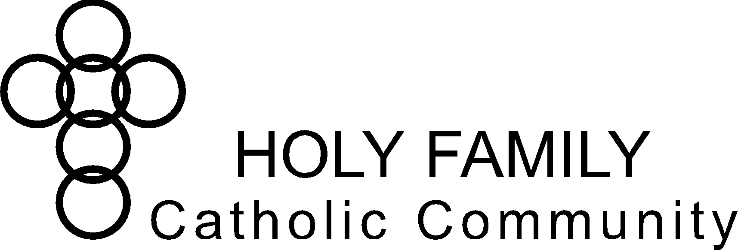

**Holy Family Catholic Community Christian Formation Commission Notes**

**August 8, 2023, 6:00pm – 7:30pm**

**Sacred Heart Victory Center**

**Commission Members:** Patti Folz, Jenny Hammis, Barb Piechowski, Andrea School, Lisa Sutton (remote)

**Pastoral Council Liaison:** Angie Raflik

**Staff & Clergy:** Sabina Carter, Eric Rudd, Trisha Zimmerman

**Absent:** Marian Freund, Jane Lueck, Pam Minsch

**Excused:** Nora Dee, Julie Baltz, Fr. Matthew Kirk, Fr. Kevin Tanel

**Opening Prayer** (Angie Raflik)

|  |  |  |
| --- | --- | --- |
| **Chair:** Angie Raflik | **Co-Chair:** Lisa Sutton | **Secretary**: Barb Piechowski |

|  |  |  |
| --- | --- | --- |
| **Holy Family Vision Statement**  To be disciples in Christ – living witness to the Good News | **Holy Family Mission Statement**  We are a Catholic community  empowered through the Holy Spirit  to love God and follow Jesus Christ  through faith, worship, and witness | **Important Dates:**  08/10/2023 Youth Group Summer Bonfire  08/14/2023 Fatima Presentation with Fr. Michael  08/27/2023 MjMj7 Concert  09/06/2023 Men’s Ministry  09/14/2023 Women’s Ministry  10/07/2023 Oktoberfest |

|  |
| --- |
| **Welcome & Framing Statement:**  This commission has three purposes:   * Accountability: *CF Commission represents Holy Family parishioners and keeps CF Staff accountable to parish/parishioner needs.* * Brainstorming: *CF Commission hears issues from CF Staff and brainstorms solutions.* * Organizing Volunteers: *CF Commission actively volunteers to help organize or coordinate in CF Staff’s areas of greatest need.* |

**Old Business:**

* + - 1. Christian Formation Report (Staff) – Questions, Highlights (rose/thorn)
* Welcome new staff Eric Rudd & Angie Bestul.
* Highlights reviewed with commission – see staff report.
* Good feedback from Steubenville conference attendees.
  + - 1. Pastoral Council Report (Liaisons)
* Last Pastoral Council meeting was in May. Council received an update on Hispanic Ministry from Fr. Pedro and an update from Finance Council.
  + - 1. Strategic Plan Discussion (Sabina)
* Plan based on 4 Signs of Dynamic Catholic is complete.
* To be released after editing.
* Strategic Plan & upcoming Adult Confirmation both based on 4 Signs of Dynamic Catholic.
  + - 1. Faith Formation for Parishioners with Disabilities (Sabina)
* Using West Bend program as a benchmark/idea builder for Holy Family future programming (on a smaller scale).
* Current special needs program is funded by Knights of Columbus tootsie roll drive.
* Instructor is looking to retire after this year.
  + - 1. “Did you Know” (Andrea)
* One person sent 2-3 ideas; Andrea came up with some more. Would like to put in the Good News.
* Commission to review prior to submitting for publish.
  + - 1. Change of Meeting Date – 2nd Tuesday of Month, Quarterly
* 6-7:30pm in the Couch Room at the Sacred Heart Victory Center

**New Business:**

One week prior to meeting – staff to submit report (Sabina to combine). Will get sent to commission with the agenda.

Commission Book Read – *Beautiful Eucharist* by Matthew Kelly

* Sabina will order for the commission and arrange for Commission members to pick up books.
* Lisa will come up with a reading plan & discussion question for next 3 meetings.

Opening/Closing prayers

* Angie will create a rotation with Commission members going forward.

Looking to sponsor a kids/craft at sites other than Holy Family whenever there is a special event. Holy Family’s includes a 2-3 min video, talk & craft (total of about 15 min). Ask around to find out if there’s anything coming up & keep Tricia posted.

* Feast days are celebrated at each site – would depend on the mass times.
* Could also align with hospitality (monthly at each site). Looking to sponsor 2-3 every year.

Tricia is putting together a list of topics for the 4 “Building Your Domestic Church” talks this year and looking for additional ideas for talks. Goal is to help families understand what the church’s expectations are for the home. Parent couples share their experiences after each talk, what works for them, etc. Ideas suggested:

* What do during Adoration
* Understanding the Holy Spirit
* How to Pray the Rosary
* How to make Advent in your home (example from Holyland, giveaway’s such as wisemen lego men – used in place of elf on a shelf)
* Reconciliation & tie into Cor Jesu

**Agenda Items for Next Meeting:**

1. Christian Formation Report (Staff) – Questions, Highlights (rose/thorn)
2. Pastoral Council Report (Liaisons)
3. Strategic Plan Discussion (Sabina)
4. Commission Book Read (All)

**Closing Prayer** (Angie)

**Next meeting:**

Tuesday, November 14, 2023

**Future meetings:**

Tuesday, January 9, 2024

Tuesday, April 9, 2024