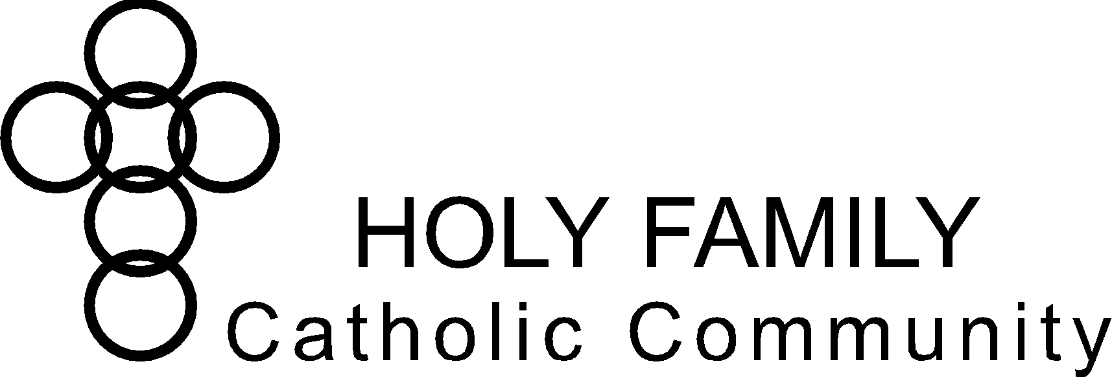
Holy Family Catholic Community Christian Formation Commission
April 20, 2023, 6:30 PM
Holy Family Board Room

Opening Prayer (Fr. Edward)
Note taker (Barb Piechowski)

Commission
* | Julie Baltz | ^ | Nora Dee | * | Patti Folz | x | Marian Freund
x | Jenny Hammis | ^ | Jane Lueck | * | Pam Minsch | ^ | Susana Ocampo
* | Barb Piechowski | * | Angela Raflik | ^ | David Ransom | x | Andrea School
x | Lisa Sutton
Christian Formation Staff & Clergy
* | Sabina Carter | x | Fr. Michael Malucha | x | Andrew Skiff | * | Fr. Edward Sanchez
x | Trisha Zimmerman
^ | Absent
x | Excused
* | Present

Holy Family Vision Statement
To be disciples in Christ – living witness to the Good News

Holy Family Mission Statement
We are a Catholic community
empowered through the Holy Spirit
to love God and follow Jesus Christ
through faith, worship, and witness

Welcome & Framing Statement:
This commission has three purposes:
- Accountability: CF Commission represents Holy Family parishioners and keeps CF Staff accountable to parish/parishioner needs.
- Brainstorming: CF Commission hears issues from CF Staff and brainstorms solutions.
- Organizing Volunteers: CF Commission actively volunteers to help organize or coordinate in CF Staff’s areas of greatest need.

Staff: (Sabina) Christian Formation Report, Issues, and Proposed/Brainstormed Solutions

Review/answer questions about Christian Formation report:
- Baptism classes - good participation/increase.
- Summer book read – Eucharist by Bishop Barron selected in advance, gives parishioners time to read ahead and prepare for discussions. Short book but may be more difficult to understand. Good choice for year of Eucharistic revival.
- Easter Vigil RCIA – 15 people total/increase from prior years.

Parish feedback regarding Christian Formation:
- Concern for keeping youth engaged after & in addition to formation classes. How to involve this demographic in solid faith experiences before they leave. Examples: How to do work like Focus Missionaries for those who may not have that encounter, build good experiences on retreats, Theology of the Body, Adoration “How to” experiences, Mission speaker testimonial, etc. Confirmation classes currently have no unifying theme. Small group models are based on “what do we do as adult Catholics”. Confirmation retreat currently engages students with those praying for them via journaling. Guided to meet with their sponsors and priests and discern when they are individually ready for Confirmation.
- Parent involvement in “Building the Domestic Church” increased in the past year.
- Continue to review curriculum from Archdiocese and compare to our resources to update format and build on small group discussions.
- Will continue to discuss and work with commission to improve our program.

Commission:
- Pastoral Council Report (Liaisons: Julie Baltz, Pam Minsch, Angela Raflik, David Ransom & Susana Ocampo)
- No Pastoral Council meeting this month. Note that this is the year of Eucharistic Revival.
- Strategic Plan discussion
- Fr. Ryan and Sarah are finalizing the roll out. Based off “The Four Signs of a Dynamic Catholic”.
- Archdiocese Commission Meeting Report
- Overview/highlights/review & discussion of Parish Commissions & Committees Manual.
- Sabina attended archdioceses meeting with other parishes.
- Reviewed potential sub committees of commission & membership.
  - Ex-officio members include staff and council liaison
  - Chairperson – seek interest from current membership prior to next meeting
  - Vice Chairperson – seek interest from current membership prior to next meeting
  - Secretary – Barb Piechowski volunteered going forward
- Human Concerns has moved towards the format outlined with chairperson & secretary as a non-staff member. Looking to do the same for Formation Commission.

- Evangelization & Formation – adult, youth (high school), young adult (up to age 39), family, vocations
- Faith Formation for Parishioners with Disabilities.
- West Bend has a solid working program. Julie willing to go observe.
- Sabina will follow up.
- Change of meeting date to a different day of week or week of month or location
- New hire in June for youth and young adult ministry
- Conflicts with youth ministry, many nights do.
- Potentially move meeting to Victory Center to allow for youth minister to attend
- Sabina to send out Jotform/Survey https://form.jotform.com/231133684750151 to current membership:
  - Are you willing to come back to the Formation Commission this year?
  - What day of the week works best for you to meet?

- Four Signs of a Dynamic Catholic discussion (pages 143-216)
- Change one thing about the world? Creativity for the Positive
- When has God won you over? – Retreats and Holy Moments
- What do you evangelize about? – Bible in the Year Podcast
- How to share our faith in others in the coming week? – shared experiences with those around us & extend invitations to parish events, be a good listener.

- Other
  - 6/23/2023 – team to provide a meal/luncheon for catechists
  - Follow up on “Did You Know” about the mass in the Good News – submit ideas to Andrea School

Closing Prayer (Sabina)

Next meeting: TBD
Future meetings: TBD
Reference:

April Staff report
https://docs.google.com/document/d/11F9rhR4fAVp2F2tsmwTjIKjpxVjT52cgIHAokSHNOjw/edit?usp=sharing

Arch MKE Parish Commissions and Committees Manual
https://docs.google.com/document/d/1NRw_7X5c_cCCJRfegJE7er_FquKS1Q4dEIpdwi_QjXQ/edit?usp=sharing

Four Signs of a Dynamic Catholic Discussion Guide
https://docs.google.com/document/d/1FNkkHoGMRlEzwuTD4gx7kl1UKFicxNM5/edit?usp=sharing&ouid=113997267306758817328&rtpof=true&sd=true

